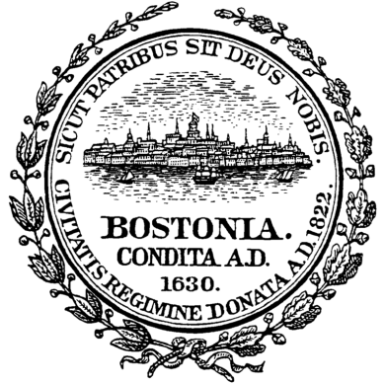
GUIDELINES FOR DISPOSING OF TRASH AND RECYCLING
IN THE SOUTH END

1. Pick-up Schedule: Trash is collected on Tuesday and Friday. Recycling is collected ONLY on Tuesday.

2. Timing: All trash and recycling must be placed in front of your property or at the rear of your property in the alley no earlier than 5:00 PM (unless located within the Placement Pilot Program area which is 9:00PM) on the day before collection or no later than 7:00 AM on collection day. Do not place any trash or recycling at the corner of your street. Please do not put anything in the tree pits as it compacts the soil and reduces water absorption.

3. Secured: All trash and recycling must be properly “secured” in order to prevent items from
being blown around by the wind and littering the neighborhood. “Secured” means using plastic
bag no larger than 32 gal. and tying it securely or using a container with a lid.

Trash: use any color except clear: Recycling: use only clear. Do not use grocery store paper bags, flimsy plastic bags, shopping bags , cardboard boxes,
etc. If used, Code Enforcement may ticket you.

4. Blue Bins: Contents must not overflow the brim. If there is excess, simply line the bin with a
clear plastic bag. Instead of using the bin, consider using a larger recycling container lined with a
clear plastic bag. Do not place any loose items e.g. pizza boxes on top of the bin.

5. Neighbors: New owners and renters may not know how to prepare trash and recycling so
please share these simple rules. If you see neighbors acting irresponsibly, remind them that
abiding by these rules will ensure a cleaner neighborhood even if they disagree with the
current policies.

6. Trash Scavengers: It is illegal and difficult to issue fines to them. Scavengers kick trash bags
to hear the sound of metal or glass. If heard, they rip open the bag searching for returnable bottles
and cans often strewing trash on the street. Placing all recyclables in clear plastic reduces this
problem.

7. CEP: Code Enforcement Police circulate throughout the South End every Tuesday beginning
at 7 AM and a smaller force on Friday. Since spring 2013 hundreds of tickets have been issued
and CEP are now specifically targeting repeat offenders. Building owners are ultimately
responsible to the city and the Housing Court for all violations. If you have renters, be
sure to share this information in your rental contract.

8. Code Enforcement Issues: Report violations by calling the Mayor’s 24/7 Hotline: 617-635-
4500 or by using Citizen’s Connect.

9. Appeal Process: If you received a citation and want to dispute the violation or the amount,
you must appeal the ticket by sending a written request for a hearing to: The Clerk Magistrates
Boston Housing Court, 24 New Chardon Street, Boston, MA 02114. You will be notified of a
hearing date. The Code Enforcement Division does not have the legal authority to simply
dismiss or waive any issued violation regardless of circumstances; an appeal must be submitted.
For more information, contact the Code Enforcement Division at 617-635-4896.

