Columbus Avenue Parking Regulation Changes

The Mayor’s Office of Neighborhood Services and Boston Transportation Department have received many requests from neighbors and businesses to examine the unregulated parking on both sides of Columbus Avenue from Dartmouth to Melnea Cass. Through neighborhood input Boston Transportation has proposed adding South End Resident Spaces and 2 Hour Visitor Parking.*
For more information please contact Tabitha Bennett, Mayor’s Office of Neighborhood Services (617) 635-3485 or tabitha.bennett@cityofboston.gov
Proposed changes:
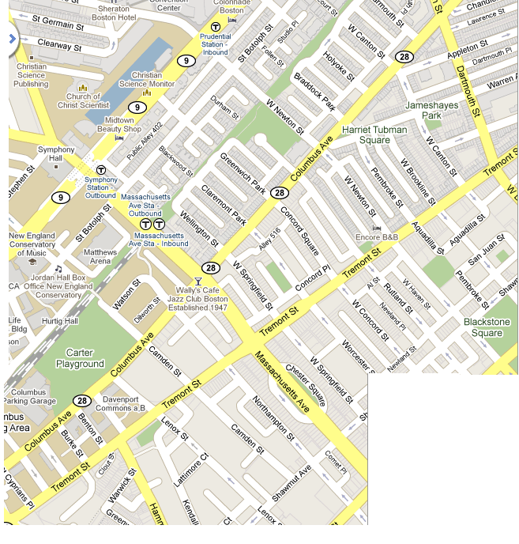
Key
South End 24 hour Resident Parking w/ 30% visitor mix*

2 Hour Visitor
Parking Mon-Fri 8am-6pm

No Change
Please Note: Loading Zones, Handicap Spaces, Rush Hour Restrictions and Valet Spaces will remain the same.
Reasons for this change include:
- 2 hour visitor spots will encourage turn over in front of businesses, making spaces available more often to customers
- 2 hour visitor spots and resident spots will cater to residents, customers, and business owners rather than commuters who park all day only to walk to and from the train
- Residents of the South End will have spaces available on Columbus Avenue
*Roxbury Resident/Visitor Parking will be installed from Burke Street toward Melnea Cass. Since other Roxbury resident parking begins at Hammond Street, this is consistent with existing signage.
Turn this flyer over for instructions on obtaining a South End Resident Parking Sticker
Resident Parking Permit (www.cityofboston.gov/parking/residentparking/)

Boston's Resident Permit Parking Program is an initiative designed to give residents a better chance of finding an on-street parking space in their neighborhood. Many of the parking spaces on Boston's residential streets are regulated as "Resident Parking Only." A smaller number of parking spaces on these same streets are posted as "Visitor Parking" areas for the guests of neighborhoods residents. Residents who live in areas where parking is regulated for residents only must apply for a Resident Parking Permit to avoid receiving parking tickets.

All outstanding City of Boston parking tickets must be paid before applying for or renewing a resident parking permit.

Permits are distributed by the Office of the Parking Clerk, Room 224, City Hall. Residents, or their representatives, must apply in person Monday through Friday, between the hours of 9:00 AM and 4:30 PM.

New Applicants:
You may download the necessary Resident Permit Application (http://www.cityofboston.gov/parking/residentparking/apply.asp) and bring it to City Hall. In addition to the application form, the following two pieces of information must be presented at the Office of the Parking Clerk when applying for a permit:
1. A valid Massachusetts automobile registration showing your car registered and principally garaged in your name from your current Boston address.
2. One of the following proofs of residency bearing your name and Boston address. The proof of residency must be current - postmarked within the past 30 days.
- Gas, Electric or Telephone Bill
- Cable Television Bill
- Monthly Bank Statement (excluding mortgage)
- Credit Card Bill
- Water and Sewer Bill

Please check online for information on Resident Permit Parking renewals, change in plates, vehicle or neighborhood, information for students or rental cars.

http://www.cityofboston.gov/parking/residentparking/

For more information please contact Tabitha Bennett, Mayor’s Office of Neighborhood Services (617) 635-3485 or tabitha.bennett@cityofboston.gov

